**Gyro-pendulum**

The **Lagrangian** (see appendix A) of the gyro-pendulum is

$$L=T-U=\frac{1}{2}\left(I_{x}ω_{x}^{2}+I_{y}ω_{y}^{2}+I_{z}ω_{z}^{2}\right)-(-m_{tot}gl_{cm}cosθ)$$

where T represents the total kinetic energy of the system, and U is the potential energy. By assuming zero potential is at the pivot, we can express potential energy as $U=-m_{tot}gl_{cm}cosθ$. And given the system’s symmetry $I_{x}=I_{y}$.

We can perform a transformation from Cartesian coordinates $(x,y,z)$ to **Euler angles $(θ,ϕ,ψ)$** (see appendix B), rendering the Lagrangian as:

$$L=\frac{1}{2}\left(I_{x}\left({\dot{θ}}^{2}+{\dot{ϕ}}^{2}\sin^{2}{θ}\right)+I_{z}{\left(\dot{ϕ}cosθ+{\dot{ψ}}^{2}\right)}^{2}\right)+m_{tot}gl_{cm}cosθ$$

Applying to the **Euler-Lagrangian equations** (see appendix A), we derive:

$$\left\{\begin{aligned}M_{θ}=I_{x}\ddot{θ}+\left(I_{z}-I_{x}\right){\dot{ϕ}}^{2}\sin{θ}\cos{θ}+I_{z}\dot{ϕ}\dot{ψ}\sin{θ}+m_{tot}gl_{cm}\sin{θ}) \\ M_{ϕ}=\left(I_{x}\sin^{2}{θ}+I_{z}\cos^{2}{θ}\right)\ddot{ϕ}+2\left(I_{x}-I_{z}\right)\dot{θ}\dot{ϕ}\sin{θ}\cos{θ}+I_{Z}(\cos{θ}\ddot{ψ}-\sin{θ}\dot{θ}\dot{ψ}) \\ M_{ψ}=I_{z}\left(\ddot{ϕ}\cos{θ}-\dot{ϕ}\dot{θ}\sin{θ}+\ddot{ψ}\right)\end{aligned}\right.$$

Where $M$ signifies the torque applied to the system along each coordinate axis.

In this specific scenario, $M_{θ}=M_{ϕ}=0$, while $M_{ψ}$ is the output torque of the motor, which depends on the input voltage, input current, load, and gearbox ratio.

$I_{z}=\frac{π}{2}ρ_{al}(R^{4}H-r^{4}h)$ The moment of inertia of the flywheel with respect to its central axis.

$$I_{x}=\frac{1}{3}m_{5}l_{5}^{2}+\left(\frac{1}{12}m_{6}l_{6}^{2}+m_{5}d_{5}^{2}\right)+\left(\frac{1}{12}m_{8}l_{8}^{2}+m_{8}d_{8}^{2}\right)+\left(m_{71}\left(3\left(R^{2}+r^{2}\right)+h^{2}\right)+m_{71}d_{71}^{2}+\frac{1}{12}m_{72}{\left(H-h\right)}^{2}+m_{72}d_{72}^{2}\right)+(\frac{1}{6}m_{12}a^{2}+m_{12}d_{12}^{2})$$

The moment of inertial of the pendulum around x axis, $m_{x}$ denotes the mass of part x, $l_{x}$ the length of part x, and $d_{x}$ the distance from the centre of mass of part x to the pivot. Part 12 represents the load (camera), which is assumed to be a box with side length $a$.

Given all these considerations, we can proceed to solve the set of differential equations in Python.

Appendix A

**Lagrangian Mechanics**

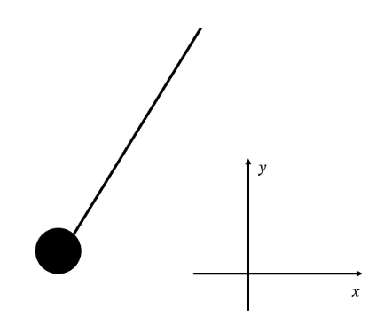Newtonian mechanics can be applied to derive the dynamics equation of a simple pendulum:

$$\left\{\begin{aligned}\begin{aligned}T\frac{y}{\sqrt{x^{2}+y^{2}}}-mg=m\ddot{y} \\ T\frac{x}{\sqrt{x^{2}+y^{2}}}=m\ddot{x}\end{aligned} \\ x^{2}+y^{2}=l^{2}\end{aligned}\right.$$

This set of equations may appear complex. By introducing a new coordinates $θ$, the equations can be simplified as follows:

$$ml\ddot{θ}-mgθ=0$$

The equation effectively describe the motion of a simple pendulum, allowing us to eliminate T (constraint force) by using a new coordinate system.

In analytical mechanic (Lagrangian mechanics, in this case), one of the aims is to eliminate the constraint force by switching to appropriate coordinates, as we did for the pendulum.

Understanding Constraint Force

To eliminate constraint force, we must understand its nature. A key characteristic of constraint forces is that they typically don’t do work because their direction is usually perpendicular to the motion. An example includes the tension T in the pendulum or the normal force when a ball rolls on a surface.

To illustrate this, we introduce the concept of virtual displacement $δ\vec{r}$, which “shows how the mechanical system's trajectory can hypothetically (hence the term virtual) deviate very slightly from the actual trajectory $\vec{r}$ of the system without violating the system's constraints. For every time instant $t$, $δ\vec{r}$ is a vector tangential to the configuration space at the point $\vec{r}$. The vectors $δ\vec{r}$ show the directions in which $\vec{r}$ can "go" without breaking the constraints. For example, the virtual displacements of the system consisting of a single particle on a two-dimensional surface fill up the entire tangent plane, assuming there are no additional constraints.” (From Wikipedia)

The virtual work is simply the dot product of force and virtual displacement. Typically, an idealized constraint force is perpendicular to the trajectory, while the virtual displacement represents potential trajectories. As such, the dot product of these vectors is zero. This implies that the total virtual work performed by the constraint force on a dynamic system is zero.

D'Alembert principle

For an arbitrary system, Newton’s second law states: $\vec{F}+\vec{N}=m\ddot{\vec{r}}$, where $\vec{F}$ denotes motive force/resultant non-constraint force, while $\vec{N}$ represents the constraint force. Apply(Multiply) virtual displacement to equation, we get $\vec{Ḟ}∙δ\vec{r}+\vec{N}∙δ\vec{r}=m\ddot{\vec{r}}∙δ\vec{r}$. Considering the principle that the total virtual work done by the constraint force on a dynamic system is zero ($\vec{N}∙δ\vec{r}=0$), wecan rearrange these equations. Apply this to a multi-particle system yields $\sum{\left(\vec{F_{i}}-m_{i}{\ddot{\vec{r}}}_{i}\right)∙δ{\vec{r}}_{i}=0}$. This equation essentially represents D'Alembert principle.

Euler-Lagrangian equation

For a system consisting of n particle and q constraints, we need $s=3n-q$ independent coordinates $q_{1}, q_{2}, ….q_{s}.$ to describe it. Each particle’s position ${\vec{r}}_{i}$ can be expressed as a function of these coordinates and time ${\vec{r}}_{i}={\vec{r}}_{i}\left(q_{1}, q_{2}, …, q_{s}, t\right)$, where $i$ is from 1 to n.

We can express the differential ${d\vec{r}}_{i}$ in terms of the differentials of the generalized coordinates and time. ${d\vec{r}}_{i}=\frac{∂{\vec{r}}_{i}}{∂q_{1}}dq_{1}+\frac{∂{\vec{r}}_{i}}{∂q_{2}}dq_{2}+\frac{∂{\vec{r}}_{i}}{∂q_{3}}dq_{3}+…+\frac{∂{\vec{r}}_{i}}{∂q_{s}}dq_{s}+\frac{∂{\vec{r}}_{i}}{∂t}dt$. Which means ${δ\vec{r}}_{i}=\sum{\frac{∂{\vec{r}}_{i}}{∂q_{α}}dq_{α}}+\frac{∂{\vec{r}}_{i}}{∂t}dt$. Noting that virtual displacement happen without consuming any time ($dt=0$), we obtain ${δ\vec{r}}_{i}=\sum{\frac{∂{\vec{r}}_{i}}{∂q_{α}}δq_{α}}$.

Substituting this into D’Alembert principle, we get $\sum{(\left(\vec{F_{i}}-m_{i}{\ddot{\vec{r}}}_{i}\right)\sum{\frac{∂{\vec{r}}_{i}}{∂q_{α}}δq_{α})}=0}$. Rearranging gives $\sum_{α}{\sum_{i}{\left(\vec{F_{i}}-m_{i}{\ddot{\vec{r}}}_{i}\right)\frac{∂{\vec{r}}_{i}}{∂q_{α}}δq_{α}}}=0$. Since the coordinates $q_{α}$ are independent of each other, we can simplify to $\sum_{i}{\left(\vec{F_{i}}-m_{i}{\ddot{\vec{r}}}_{i}\right)\frac{∂{\vec{r}}_{i}}{∂q_{α}}}=0 (1)$.

To further generalize the equation (1), we define the generalized force $Q_{α}= \sum_{i}{\vec{F_{i}}\frac{∂{\vec{r}}_{i}}{∂q_{α}}}$. This can be thought of as the force or torque that depends on the coordinates.

For the remaining term in (1), $\sum_{i}{m_{i}{\ddot{\vec{r}}}_{i}\frac{∂{\vec{r}}_{i}}{∂q_{α}}}$, we can apply the rule of integration by parts:

$$\sum_{i}{m_{i}{\ddot{\vec{r}}}_{i}\frac{∂{\vec{r}}_{i}}{∂q_{α}}}=\frac{d}{dt}\left(\sum_{i}{m_{i}{\dot{\vec{r}}}_{i}·\frac{∂{\vec{r}}_{i}}{∂q_{α}}}\right)-\sum_{i}{m_{i}{\dot{\vec{r}}}_{i}·\frac{d}{dt}\frac{∂{\vec{r}}_{i}}{∂q_{α}}}$$

Substituting $\frac{∂{\vec{r}}_{i}}{∂q_{α}}= \frac{∂\dot{{\vec{r}}_{i}}}{∂\dot{q_{α}}}$, and $\frac{d}{dt}\frac{∂{\vec{r}}_{i}}{∂q_{α}}=\frac{∂\dot{{\vec{r}}_{i}}}{∂q_{α}}$,

$$\sum_{i}{m_{i}{\ddot{\vec{r}}}_{i}\frac{∂{\vec{r}}_{i}}{∂q_{α}}}=\frac{d}{dt}\left(\sum_{i}{m_{i}{\dot{\vec{r}}}_{i}\frac{∂{\dot{\vec{r}}}_{i}}{∂\dot{q_{α}}}}\right)-\sum_{i}{m_{i}{\dot{\vec{r}}}_{i}\frac{∂\dot{{\vec{r}}_{i}}}{∂q_{α}}}$$

Introducing total kinetic energy of the system $T=\frac{1}{2}\sum_{i}{m_{i}{\dot{\vec{r}}}_{i}^{2}}$, where $\frac{∂T}{∂q_{α}}=\sum_{i}{m_{i}{\dot{\vec{r}}}_{i}\frac{∂\dot{{\vec{r}}_{i}}}{∂q_{α}}}$, $\frac{∂T}{∂{\dot{q}}_{α}}=\sum_{i}{m_{i}{\dot{\vec{r}}}_{i}\frac{∂\dot{{\vec{r}}_{i}}}{∂\dot{q_{α}}}}$, so

$$\sum_{i}{m_{i}{\ddot{\vec{r}}}_{i}\frac{∂{\vec{r}}_{i}}{∂q_{α}}}=\frac{d}{dt}\frac{∂T}{∂{\dot{q}}_{α}}-\frac{∂T}{∂q_{α}}$$

Back to $\sum_{i}{\left(\vec{F_{i}}-m_{i}{\ddot{\vec{r}}}_{i}\right)\frac{∂{\vec{r}}_{i}}{∂q_{α}}}=0$, we can alter the equation with generalized force and kinetic energy: $Q_{α}-$ ($\frac{d}{dt}\frac{∂T}{∂{\dot{q}}_{α}}-\frac{∂T}{∂q_{α}})=0$.

$$\frac{d}{dt}\frac{∂T}{∂{\dot{q}}_{α}}-\frac{∂T}{∂q_{α}}=Q_{α}$$

If only conservative forces act on the system, we can introduce potential energy $U$. Conservative forces can be expressed as $\vec{F_{i}}=-\frac{∂U}{∂\vec{r_{i}}}$. So the generalized force is $Q_{α}=\sum_{i}{-\frac{∂U}{∂\vec{r_{i}}}·\frac{∂\vec{r_{i}}}{∂q_{α}}}=-\frac{∂U}{∂q_{α}}$. This gives the equation

$$\frac{d}{dt}\frac{∂T}{∂{\dot{q}}_{α}}-\frac{∂T}{∂q_{α}}=-\frac{∂U}{∂q_{α}}$$

Rearrange (noting that U is independent of generalized velocity):

$$\frac{d}{dt}\frac{∂(T-U)}{∂{\dot{q}}_{α}}-\frac{∂(T-U)}{∂q_{α}}=0$$

Here, the quantity $L=T-U$ is defined as the Lagrangian of the system. So, we have

$$\frac{d}{dt}\frac{∂L}{∂{\dot{q}}_{α}}-\frac{∂L}{∂q_{α}}=0$$

which is the Lagrangian equation for a conservative system.

For a non-conservative system, the Lagrangian equation should be written as $$\frac{d}{dt}\frac{∂L}{∂{\dot{q}}_{α}}-\frac{∂L}{∂q_{α}}=Q_{α}$$

Where $Q_{α}$ represents non-conservative generalized force applied on the system.

Appendix B

**Euler angle**

To adequately describe the motion of our system, we need to identify the most suitable coordinate system and apply it to the Lagrangian equations. For the gyro-pendulum, Euler angles appear to be an optimal choice.

I will just copy what Brian wrote before:

(Summary diagram of the of the geometries of Euler angles discussed in the following)

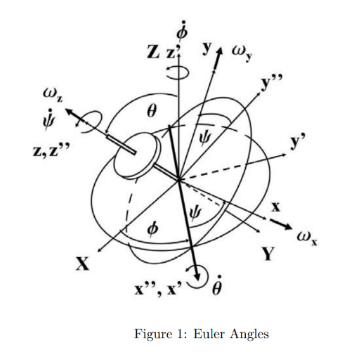

One can describe the spatial orientation of a rotating body through the use of Euler angles: spin ψ, nutation θ and precession φ.

Consider (X,Y,Z) to be the original stationary reference axes and they are transformed into the rotated axes (x,y,z) in 3 rotations.

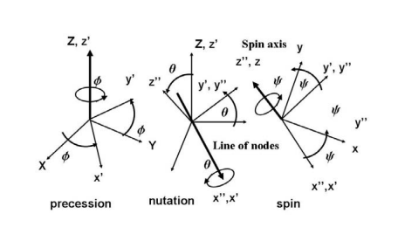

(x',y',z') is a set of orthogonal axes obtained by rotating (X,Y,Z) about Z-axis by φ.

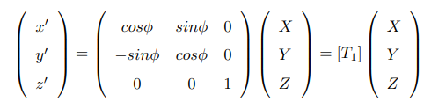

(x'',y'',z'') a set of orthogonal axes obtained after rotating (x',y',z') about x'-axis by θ.

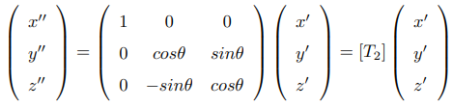

(x,y,z) are the body-fixed axes, obtained after rotating (x'',y'',z'') about z''-axis by ψ.

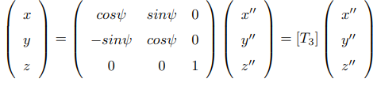

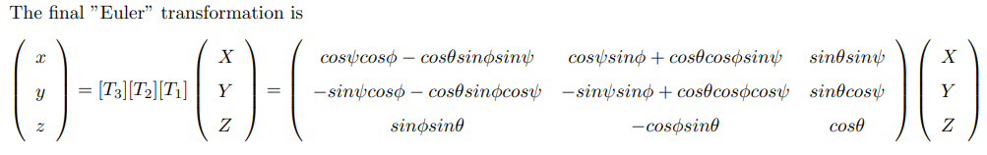

And general expression of angular speeds in the (x,y,z) coordinates may be obtained as,

